**Black Box Testing**

Control Class to be tested: UserController

Application logic to be tested: Bookmark/Unbookmark a flat

|  |  |  |
| --- | --- | --- |
| Action from User | Expected Output | Actual Output |
| Click on the bookmark icon on the upcoming-launch BTO flat in Woodlands, which was not bookmarked. | UserController get the user, and goes into the file of the user and gets the bookmark list. The clicked flat's bookmark is not in the bookmark list, so it is now added to the bookmark list of the user. A notification toast "Bookmarked this flat" is shown. | UserController get the user, and goes into the file of the user and gets the bookmark list. The clicked flat is not in the bookmark list, so it is now added to the bookmark list of the user. A notification toast "Bookmarked this flat" is shown. |
| Click on the bookmark icon on the upcoming-launch BTO flat in Tengah, which was bookmarked. | UserController get the user, and goes into the file of the user and gets the bookmark list. The clicked flat's bookmark is already in the bookmark list, so it is now deleted from the bookmark list of the user. A notification toast "Unbookmarked this flat" is shown. | UserController get the user, and goes into the file of the user and gets the bookmark list. The clicked flat is already in the bookmark list, so it is now deleted from the bookmark list of the user. A notification toast "Unbookmarked this flat" is shown. |

**White Box Testing**

firebaseAuthwithGoogle()

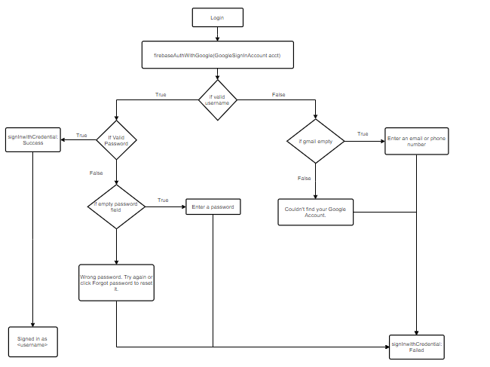

Cyclomatic Complexity :

CC(equation 2) = Decision points + 1

     = 4 + 1 = 5

5 Basis Paths

1. 1, 2, 3, 4, 5
2. 1, 2, 3, 6, 7, 10
3. 1, 2, 3, 6, 8, 9
4. 1, 2, 11, 13
5. 1, 2, 11, 12, 14

5 Test Cases

1. Logging in with Google Account with correct credentials
2. Logging in with correct google account username but left password field empty
3. Logging in with correct google account username but incorrect password.
4. Logging in with google account username empty.
5. Logging in with incorrect google account username.

5 Real Execution Paths.

1. 1, 2, 3, 4, 5
2. 1, 2, 3, 6, 7, 10
3. 1, 2, 3, 6, 8, 9
4. 1, 2, 11, 13
5. 1, 2, 11, 12, 14

FilterFlats()

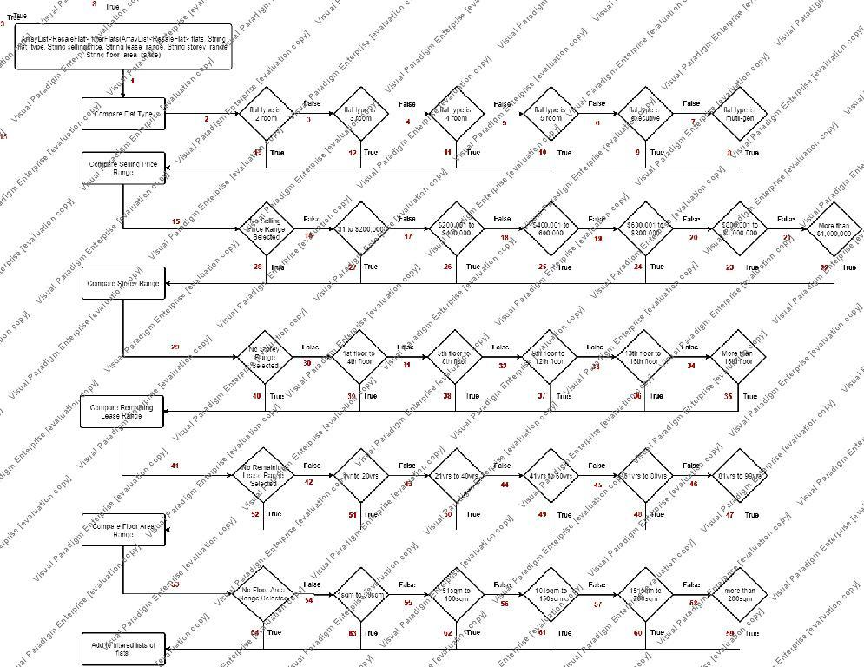

Cyclomatic Complexity :

CC(equation 2) = Decision points + 1

     = 31 + 1 = 32

32 Basis Paths

1. 1,2,13,15,28,29,40,41,52,53,64

…….

1. 1,2,3,4,5,6,7,8,15,16,17,18,19,20,21,22,29,30,31,32,33,34,35,41,42,43,44,45,46,47,53,54,55,56,57,58,59

32 Test Cases:

1. Flat Type: 2 Room Flat, No filters for remaining filter types

…….

1. Flat Type: Multi Generation, Selling Price Range>$1,000,000, Storey Range >16th Floor, Remaining Lease Range: 81 years to 99 years, Floor Area Range, more than 200sqm.